Lab 9: Software Interrupts, Hooking Software Interrupts & Exceptions Learning Outcomes
- Students will know about interrupts and their types.
- Students will know how software interrupts are invoked.
- Students will know how software interrupts are serviced.
- Students will know various DOS and BIOS interrupts.
- Students will be able to hook interrupts.
- Students will be able to handle exceptions.

Interrupts

The notion of "interrupt" was originally conceived to allow devices to interrupt the current operation of the CPU. For example, whenever a key is pressed, the 8086 must be notified to read a key code from the keyboard buffer. Such interrupts are called hardware interrupts. On the other hand, the software interrupts are generated by the programs to get a service from the operating system or the BIOS. For example, to read a file from disk or a character from the keyboard.

Another type of interrupt is an exception, which is generated automatically when an error occurs during the execution of an instruction. For example, divide by zero or overflow.

In this manual, we are going to discuss only software interrupts. The software interrupts are invoked by using an "INT" instruction, which is followed by an interrupt number. There are 256 interrupts in the system. Some are reserved for exceptions, and the rest can be used as hardware or software interrupts.

The processor uses the interrupt number to index the Interrupt Vector Table (IVT) to get the address of a special type of procedure called an Interrupt Service Routine (ISR). The ISR is executed whenever the interrupt is generated. There are 256 entries in IVT, and each entry stores the logical address of a respective ISR. IVT resides in memory at physical address 0x00000. Each entry stores the logical address, which is 4 bytes; the total size of the IVT is 256 x 4B = 1 KB. To index the IVT, the processor multiplies the interrupt number by 4 to get the physical address of the entry against that interrupt number.

To hook an interrupt in this context means to change the ISR address of an interrupt in the Interrupt Vector Table. Before doing so, one needs to write ISR first and then add its logical address, consisting of Segment: Offset, to IVT.

ISR is a special procedure that is called whenever an interrupt is generated. Whenever an ISR is called as a result of an interrupt, the flag register is pushed onto the stack along with IP and CS. Therefore, unlike procedures, the ISRs return control by issuing "IRET" instructions instead of "RET" instructions. The IRET instruction also pops the flag register from the stack, whereas the RET instruction does not.

The control transfer to an ISR is similar to that of a procedure call. Before transferring control to the ISR, the processor first saves the address of the next instruction on the stack, called the return address. 8086 also saves the FLAG register on the stack. When the ISR returns, the FLAG register and return address are restored from the stack.

BIOS and DOS Interrupts

There are some interrupts that are provided by the BIOS to perform basic I/O operations, and some are provided by the DOS. There are multiple services against each interrupt number. The following table shows a few interrupts with few of its services. The service number is moved to the AH register before invoking an interrupt instruction. Depending on your needs, you may find more interrupts and services in your textbook.

Interrupt Vectoring

The CPU processes the INT instruction using the interrupt vector table, which, as we’ve mentioned, is a table of addresses in the lowest 1024 bytes of memory. Each entry in this table is a 32-bit segment-offset address that points to an interrupt handler. The actual addresses in this table vary from one machine to another. Figure 14-2 illustrates the steps taken by the CPU when the INT instruction is invoked by a program:

Step 1: The operand of the INT instruction is multiplied by 4 to locate the matching interrupt vector table entry.

Step 2: The CPU pushes the flags and a 32-bit segment/offset return address on the stack, disables hardware interrupts, and executes a far call to the address stored at location (10h * 4) in the interrupt vector table (F000:F065).

Step 3: The interrupt handler at F000:F065 executes until it reaches an IRET (interrupt return) instruction.

Step 4: The IRET instruction pops the flags and the return address off the stack, causing the processor to resume execution immediately following the INT 10h instruction in the calling program.

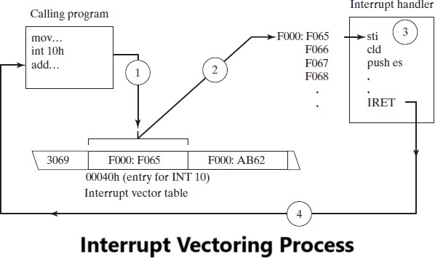

8086 Interrupt maps

When an interrupt is generated, the following steps are performed.
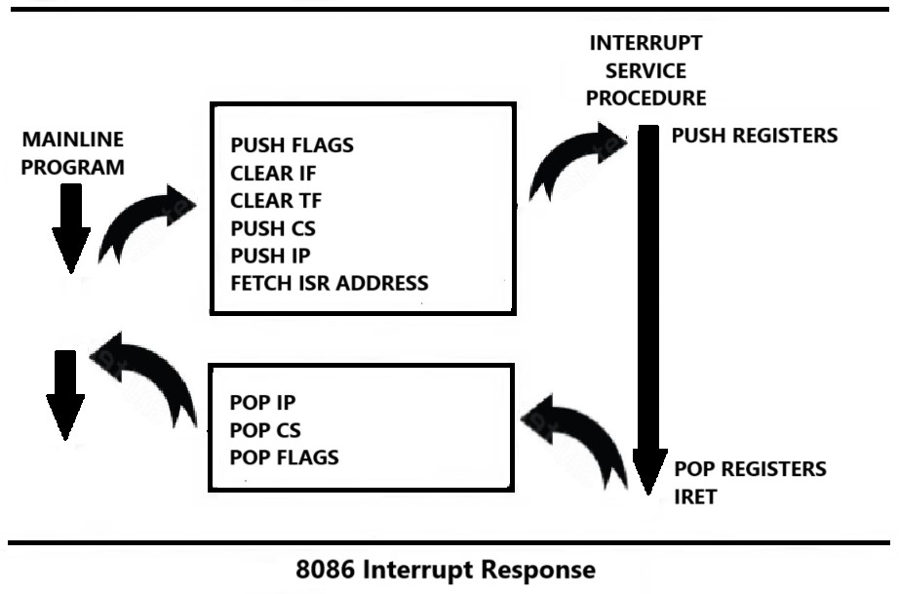
- It decrements stack pointer by 2 and pushes the flag register on the stack.
- It disables the INTR interrupt input by clearing the interrupt flag in the flag.
- It resets the trap flag in the flag register.
- It decrements stack pointer by 2 and pushes the current code segment register contents on the stack.
- It decrements stack pointer by 2 and pushes the current instruction pointer contents on the stack.
- It does an indirect jump at the start of the procedure by loading the CS and IP values for the start of the interrupt service routine (ISR).
- An IRET instruction at the end of the interrupt service procedure returns execution to the main program.
- The ISR should push registers to stack before using them and pop them before IRET.

Interrupt# | Service# | Description | BIOS/DOS
0x21 | 0x1 | read character from standard input, with echo, result is stored in AL.  if there is no character in the keyboard buffer, the function waits until any key is pressed. | DOS
0x21 | 0x7 | read character from standard input, without echo, result is stored in AL.  if there is no character in the keyboard buffer, the function waits until any key is pressed. | DOS
0x21 | 0x2 | write character to standard output device. entry: DL = Character to write.  After execution AL = DL. | DOS
0x21 | 0x9 | Print string at DS: DX on screen. String must be terminated by '$'. | DOS
0x21 | 0x4C | Terminate program and return control to DOS | DOS
0x10 | 0x2 | Set Cursor position.  DH ← ROW# DL ← COL #  BH ← Page# (i.e., 0) | BIOS
0x10 | 0x9 | Display character & attributes on current cursor position.  AL = character to display. BH = page number (i.e. 0). BL = Color attributes.  CX = number of times to write character. | BIOS

Example#1:
Program to write “Hello” on screen and terminate itself using interrupts.
.model small

.stack 100h

.data
Msg db “Hello$”
.code

Mov ax,@data Mov ds,ax

Mov ah,0x9
Mov dx,offset msg Int 0x21
;display string on screen
Mov ah,0x4c Int 0x21
;terminating program

Example#2:
Program to read a single-digit number as character from keyboard and convert it to a number and store in variable.
.model small

.stack 100h

.data n db ?
.code

Mov ax,@data Mov ds,ax
mov ah,0x1 ; read character from keyboard int 0x21
sub al,0x30 ; subtract 0x30 from the character to make it a number mov n,al ; store the number to variable
mov ah,0x4c int 0x21

Emu8086 Tutorial Step by Step Step-1
Double click on the icon on the desktop 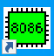

Step-2
The following window will appear. Click on “new”.
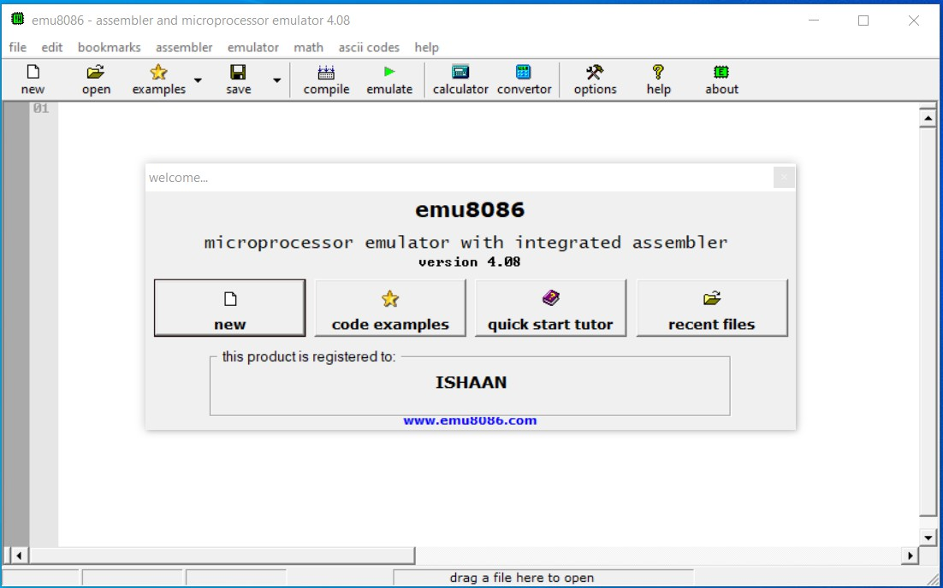

Step-3:
Click on the “empty workspace” and press “OK”.
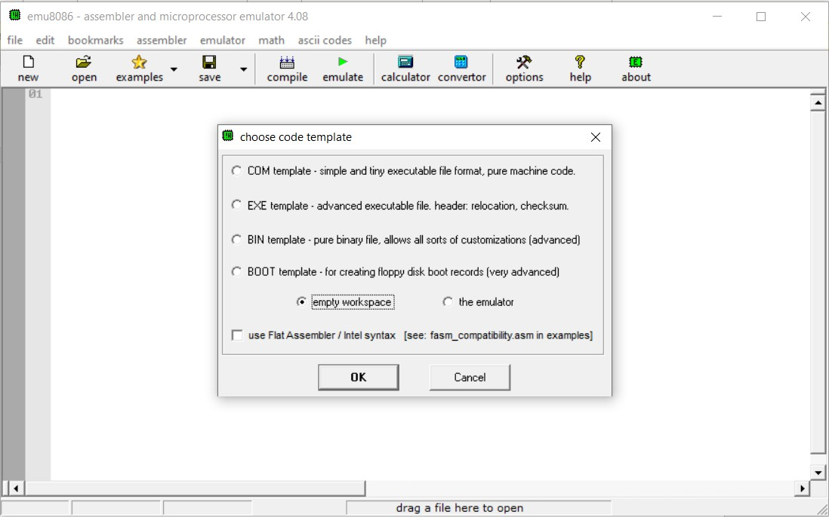

Step-4:
Type the code given in example#2 and click on “emulate”.
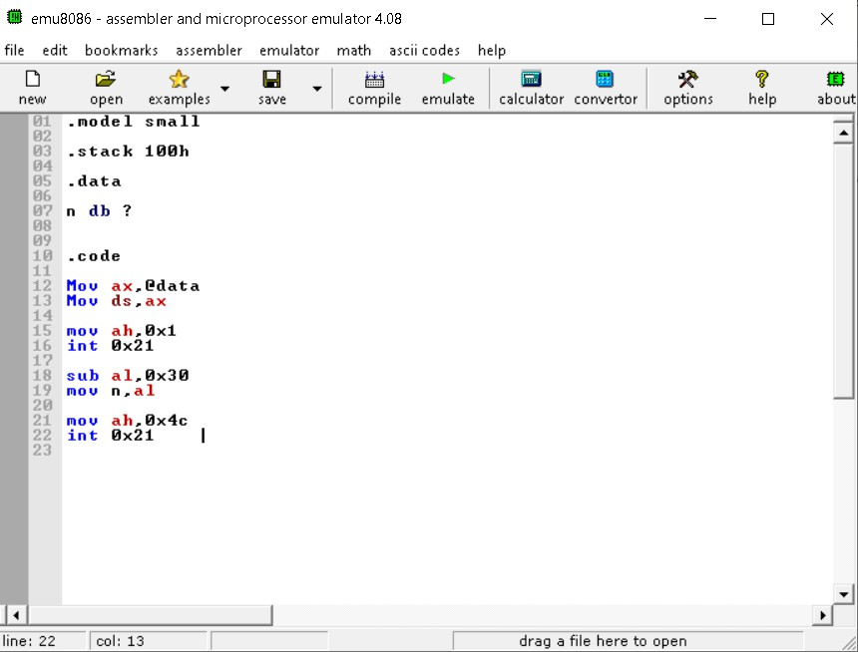

Step-5:
Click on the vars button.
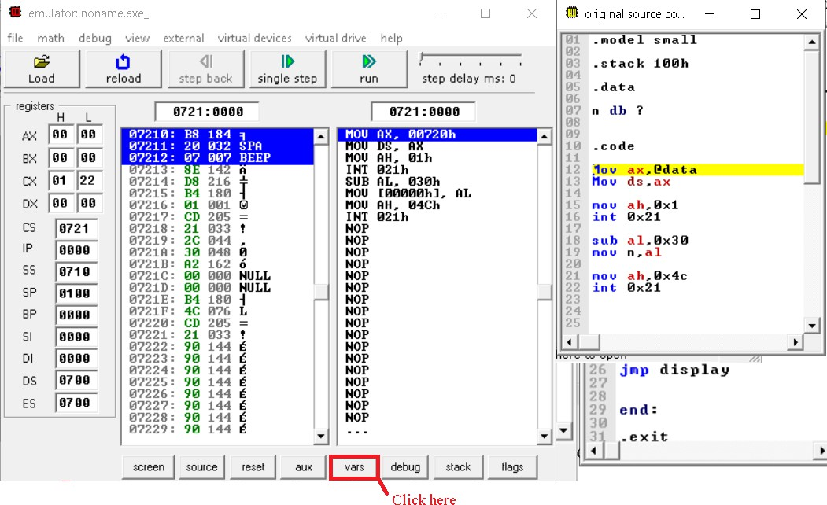

Step-6:
Keep clicking on "Single step" till the last instruction and provide input by pressing a numeric key when prompted.
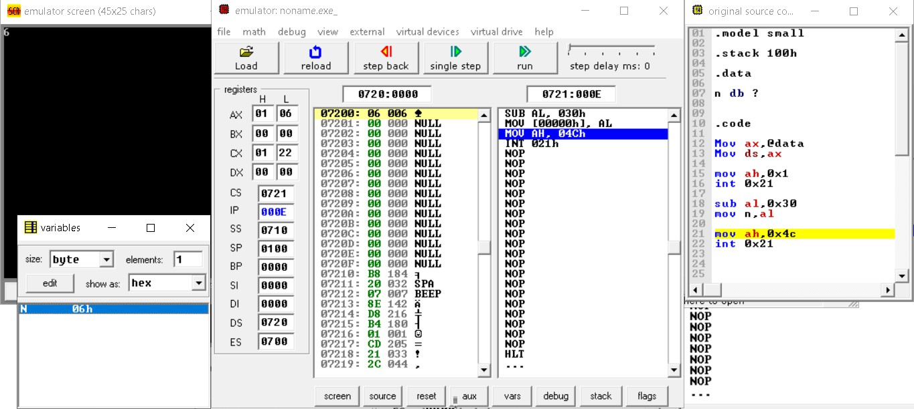

Hooking Software Interrupts & Exceptions INT#0
This interrupt is generated when a number is divided by zero or the result of division overflows. The following code handles this exception.

Example#1:
Program to write ISR for “DIV BY Zero” exception i.e., INT#0 and hook it.
.model small

.data
.code

mov ax,@data mov ds,ax

mov ax,0 mov es,ax

mov word ptr es:[0 * 4 + 0],isr0 ; offset address of ISR0 mov word ptr es:[ 0 * 4 + 2],cs ; Segment address of ISR0
mov ax,100 mov bl,0
div bl
;Dividing a number by zero to check if the hooking
.exit
ISR0 proc

jmp l@1
msg: db "Divide by Zero Exception!$" l@1:
mov dx,offset msg mov ah,9
int 0x21 IRET
ISR0 endp

INT#4
This interrupt is generated in response to an INTO instruction that checks the overflow flag to generate the interrupt. If the overflow flag is not set, INT#4 will not be generated.

Example#2:
Program to hook “OVERFLOW” exception, i.e., INT#4.
.model small

.data
.code

mov ax,@data mov ds,ax

mov ax,0 mov es,ax

mov word ptr es:[ 4 * 4 + 0],isr4 mov word ptr es:[ 4 * 4 + 2],cs

mov al,127 mov bl,1 add al,bl
into
;if OF is set, generate int#4
.exit
isr4 proc jmp l@1
msg: db "Overflow flag is set$" l@1:
mov dx,offset msg mov ah,9
int 0x21

iret
isr4 endp

Emu8086 Tutorial Step by Step Step-1
Double click on the icon on the desktop 

Step-2
The following window will appear. Click on “new”.


Step-3:
Click on the “empty workspace” and press “OK”.


Step-4:
Type the code given in example#2 and click on “emulate”.
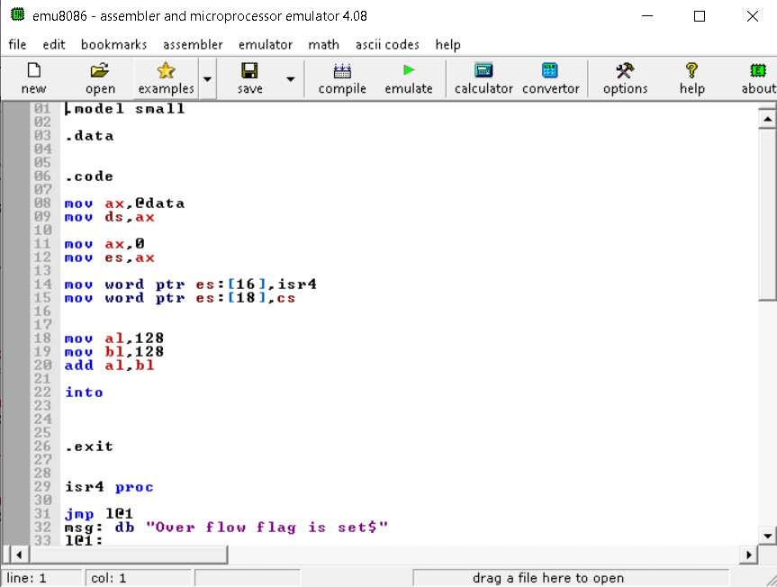

Step-5:
Keep clicking on "Single step" till the last instruction and observe the behavior of the program.
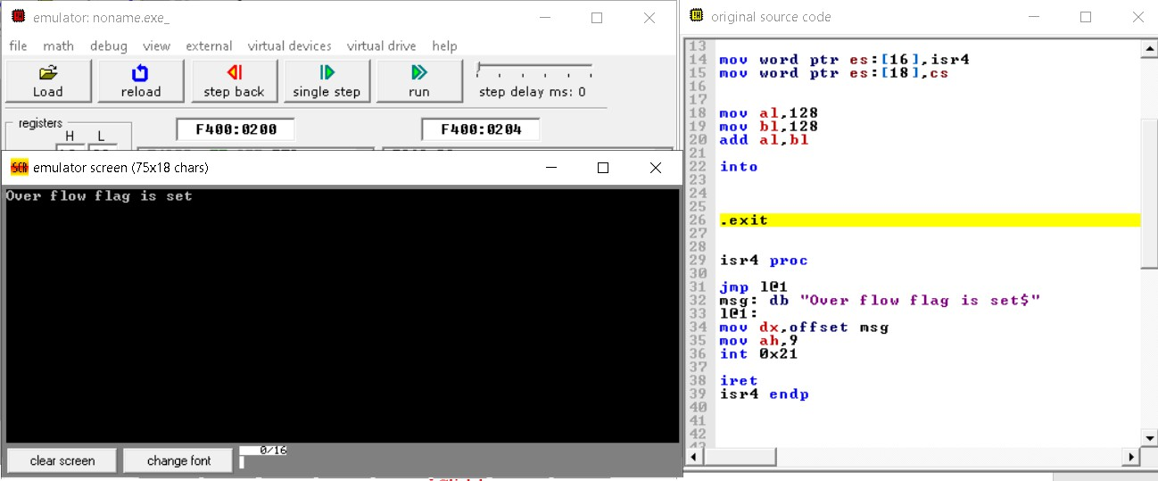

Lab-9 Exercise

Task-1
Write a code that inputs a 16-bit integer number in hexadecimal radix from the keyboard and store it in a variable.

Task-2
Write a code that prints a number stored in a 16-bit variable on screen in a hexadecimal radix.

Task-3
Write a program that inputs two 16-bit hexadecimal numbers from the user and displays their sum on the screen.

Task-4
Write a program that hooks 0x65 interrupt with the following services. The ISR should preserve all the registers except AX.

Service# | Description
0x1 | Add two words pointed by SI and DI and store the result in the memory pointed by BX.  [BX] ← [SI] + [DI]
0x2 | Multiply two words pointed by SI and DI and store result in the memory pointed by BX.  [BX] ← [SI] x [DI]
0x3 | Divide the word pointed by SI by the byte pointed by DI and store quotient and remainder in the AL and AH registers, respectively.  AL ← [SI]/[DI]  AH ← [SI] % [DI]

